Tournament Roster Directions

1. Go to www.utahyouthsoccer.net. Click on member Login. Top of website.

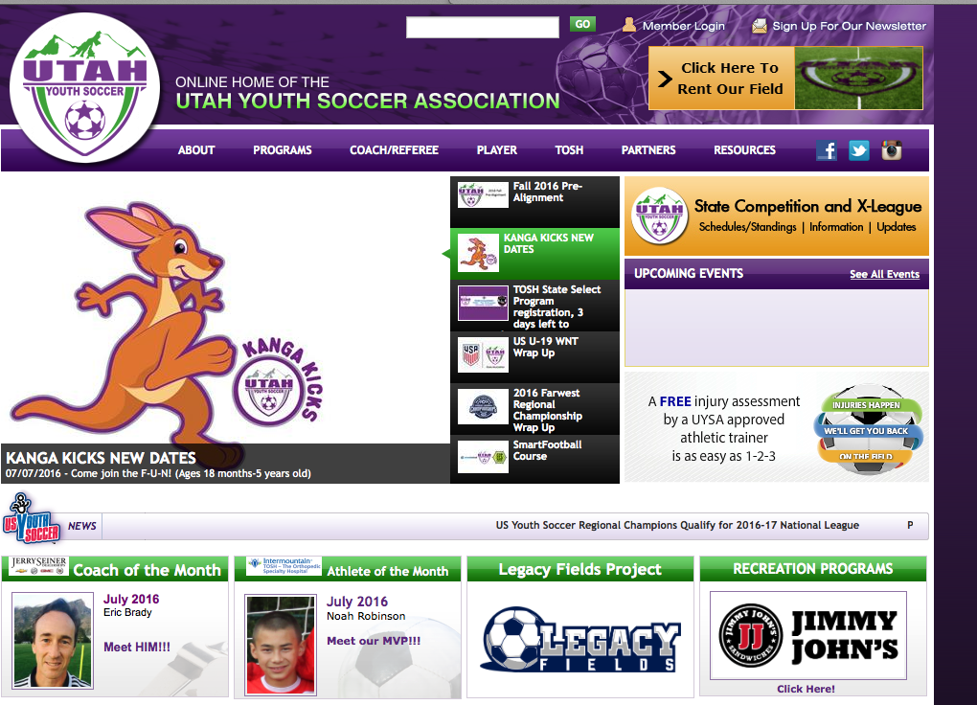
2. Login using your user name and password.

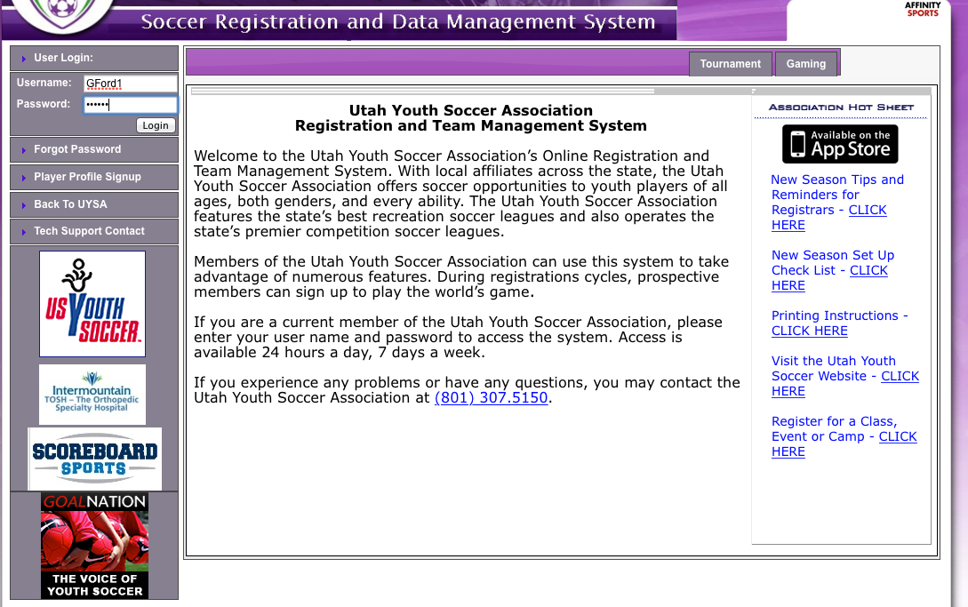

3. Select the teams tab in the middle of the page. Then click on Team Info.

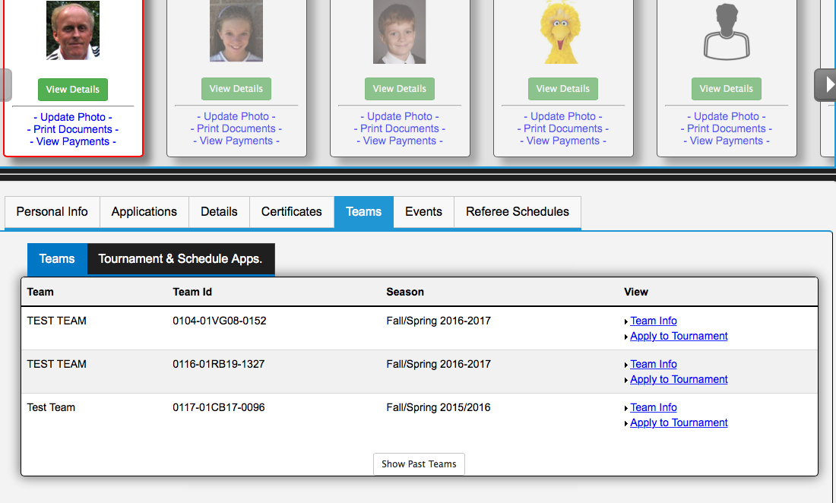

4. Click on the Tournament Roster Tab.

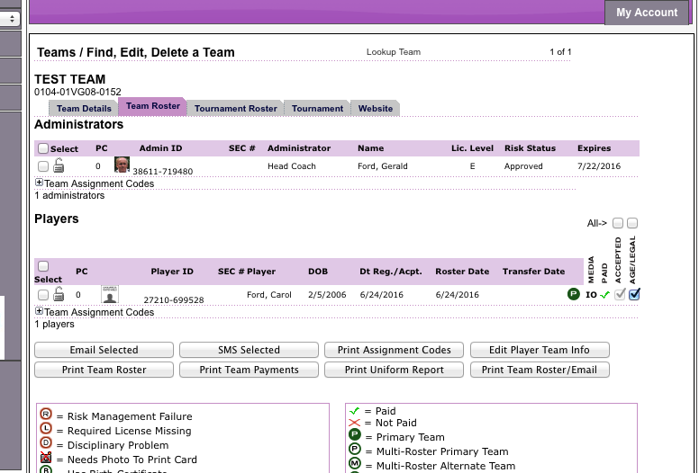

5. Enter the tournament information and save and continue.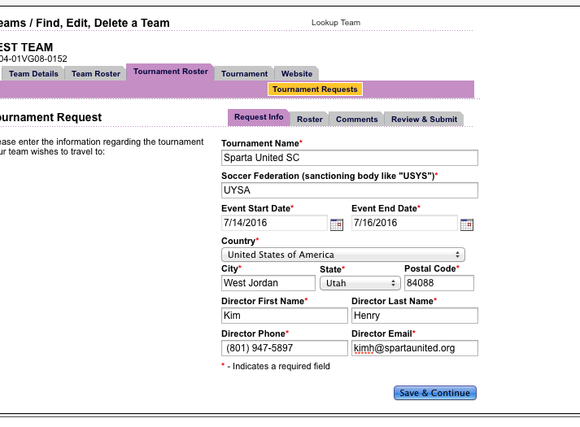

6. Add guest players and coaches by clicking on the add player/Admin inside org tab at the bottom of this page.

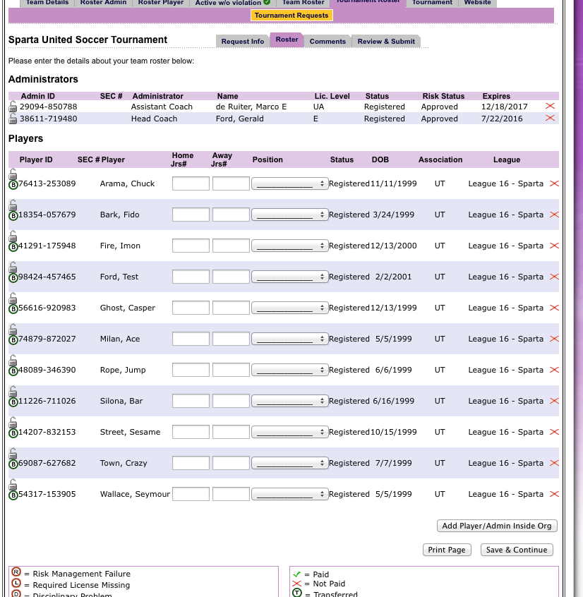

7. Click on save and continue

8. Click on submit application when all players and coaches are on this roster.

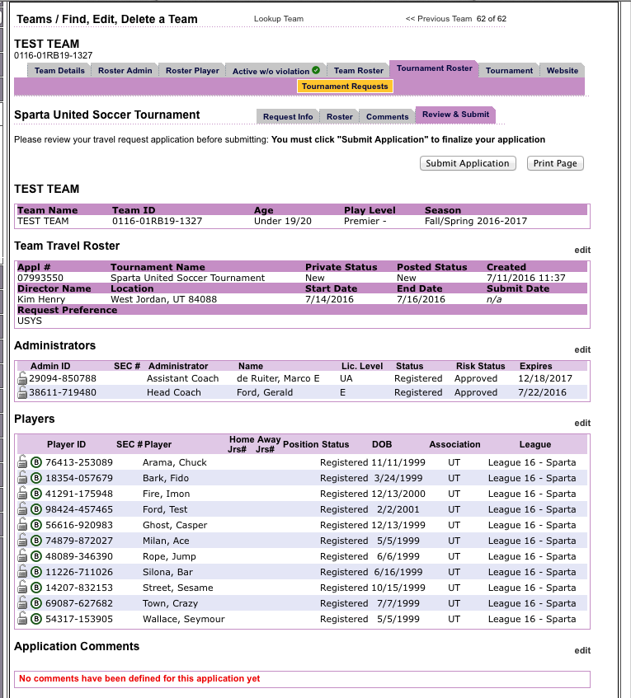

9. Click on the Print Photo Roster Tab:

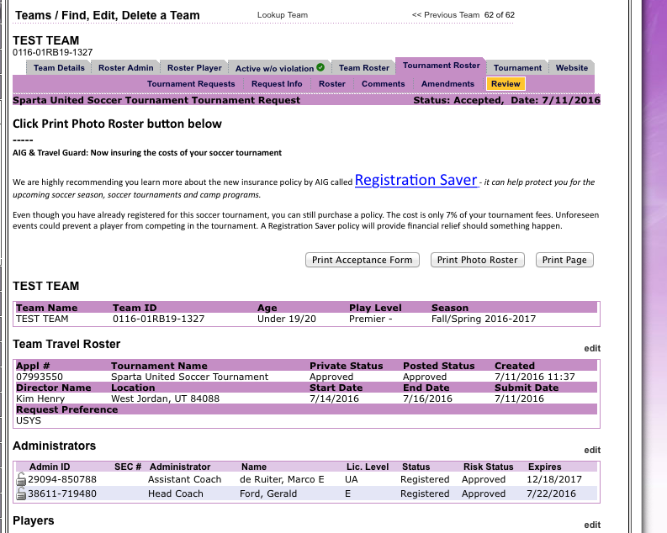

10. Export roster to .pdf. by selected .pdf from the drop down and then click on Export.
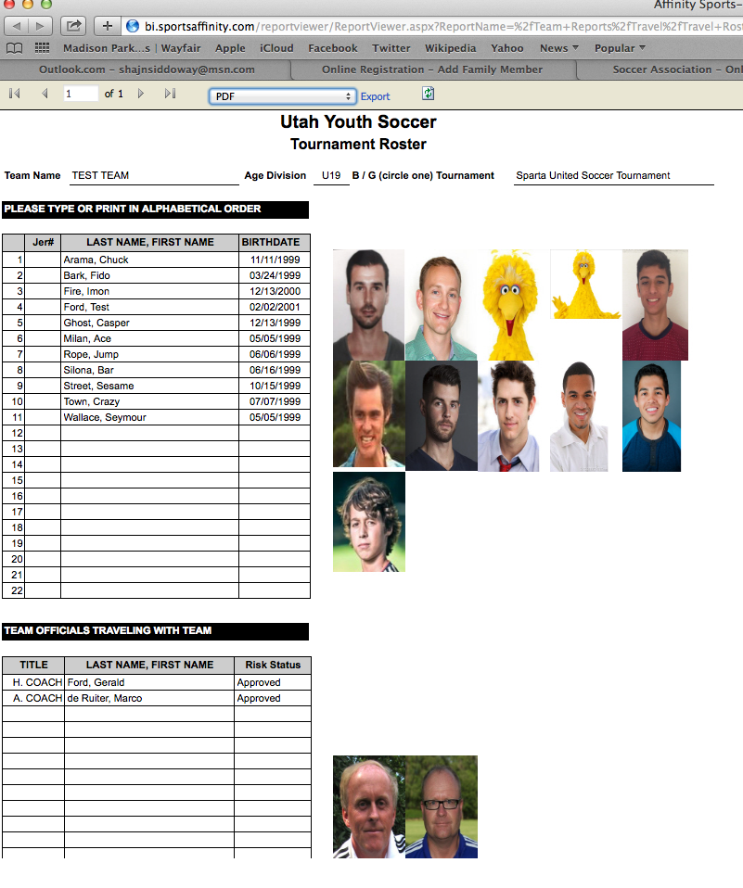

11. Print PDF. Print the number of copies required by the tournament.

